**Chapter 4**

**PRESENTATION, ANALYSIS, AND INTERPRETATION OF DATA**

This chapter presents, analyses, findings of the study together with the interpretation of the data for the purpose of answering the specific questions posted in the statement of the problem.

**1.** **Extent of Concern in Respondents’ Schools as Regards to Conflict Triggers.**

Tables 2 to 6 presents the extent of concern perceived by school heads and master teacher/teacher respondents with regard to conflict triggers in their respective schools in the areas of work assignment, promotion, professional development, interpersonal relationship, and performance evaluation.

**Table 2 Extent of Concern in the Area of Work Assignment**

|  |  |  |  |  |  |  |
| --- | --- | --- | --- | --- | --- | --- |
| **Work Assignment** | **School Heads** | | **Master Teacher/Teachers** | | **Combined** | |
| **WM** | **VI** | **WM** | **VI** | **AWM** | **VI** |
| 1. The hours I spent teaching is beyond what is required. | 3.17 | ME | 3.18 | ME | 3.18 | ME |
| 2 My teaching assignment requires more than two preparations. | 2.50 | LE | 2.34 | LE | 2.42 | LE |
| 3.The subject I teach is outside our area of specialization. | 2.17 | LE | 1.81 | LE | 1.99 | LE |
| 4 My teaching assignment in afternoon session limits my opportunity for extra economic activity for my family. | 2.33 | LE | 2.32 | LE | 2.33 | LE |
| 5. I do more clerical tasks than teaching. (e.g., accomplishing LIS forms, preparing LP, and the like) | 3.37 | ME | 3.17 | ME | 3.27 | ME |
| **Average Weighted Mean** | **2.71** | **ME** | **2.56** | **ME** | **2.64** | **ME** |

***Legend:*  4** - 3.51 – 4.00 Great Extent (GE) **2** - 1.51 – 2.50 Little Extent (LE)

**3** - **2.51** – 3.50 Moderate Extent (ME) **1** - 1.00 – 1.50 Not at All (NA)

Table 2 shows the perceptions of the respondents on the conflict triggers in their respective schools with respect to teachers work assignment. It can be observed that there was a moderate extent of concern when the teacher spent teaching beyond what is required, and teachers are doing more clerical tasks that teaching with the weighted mean of 3.17 and 3.37. On the other hand, there was a little extent of concern as perceived by the school head in terms of teaching assignment of teachers which requires more than two preparations with the weighted mean of 2.50, the subject that the teacher is teaching is outside his/her area of specialization with the weighted mean of 2.17, and the teaching assignment of teachers in afternoon session limits his/her opportunity for extra economic activity for the family with the weighted mean of 2.33, correspondingly. The above result shows that school heads perceived that there was a moderate extent of concern of the conflict trigger in the work assignment of master teacher/ teacher respondents.

In addition, it can also be seen in the table that there was a moderate extent of concern in work assignment as the hours spent in teaching beyond what is required and doing more clerical task (preparing LP, accomplishing LIS and the like) than teaching with slight difference of weighted mean of 3.18 and 3.17, respectively. On the other hand, there was a little extent of concern in the work assignment as to teacher’s assignment that requires more than two preparations, subject that the teacher teaches is outside his/her specialization, and teachers afternoon teaching assignment limits his/her opportunity for extra economic activity. The weighted mean differed in 2.34,1.81, and 2.32, respectively. The above answers can be interpreted that master teachers/teacher respondents believed that there was a moderate extent of concern in the work assignment in their respective schools.

Stanisavljevic (2014), stated that teachers or members of the school with conflict have no unity which could result to a conflicting work relationship. In this manner, the conflict between them will give distress to the school head on how to resolve such conflict. On the other hand, conflict between teachers or school employees can be beneficial to them to the point that they increase their competitiveness in each work that they are trying to accomplish and increase their critical thinking ability by giving unique ideas that could help the school.

**Table 3 Extent of Concern in the Area of Promotion**

|  |  |  |  |  |  |  |
| --- | --- | --- | --- | --- | --- | --- |
| **Promotion** | **School Heads** | | **Master Teacher/Teachers** | | **Combined** | |
| **WM** | **VI** | **WM** | **VI** | **AWM** | **VI** |
| 1. My school head endorses the teachers for promotion based on his/her assessment on teachers qualification. | 2.08 | LE | 2.11 | LE | 2.10 | LE |
| 2.My school head endorses teacher for promotion who has his/her trust and confidence. | 1.62 | LE | 1.92 | LE | 1.77 | LE |
| 3.Copies of Memos announcing the schedule of teacher’s promotion are not read by all the teachers. | 1.92 | LE | 2.07 | LE | 2.00 | LE |
| 4.Thorough evaluation by superiors of the documents submitted by teachers for promotion cannot always be done. | 2.10 | LE | 1.95 | LE | 2.03 | LE |
| 5. The “palakasan system” sometimes get a space in the promotion process due to external endorsement. | 2.25 | LE | 2.46 | LE | 2.36 | LE |
| **Average Weighted Mean** | **1.99** | **LE** | **2.1** | **LE** | **2.05** | **LE** |

***Legend:*  4** - 3.51 – 4.00 Great Extent (GE) **2** - 1.51 – 2.50 Little Extent (LE)

**3** - **2.51** – 3.50 Moderate Extent (ME) **1** - 1.00 – 1.50 Not at All (NA)

This table presents the extent of concern in the conflict trigger area of promotion of master teacher /teachers as perceived by the school heads. The results shows that there was a little extent of concern if school head endorses the teachers for promotion based on his/her assessment on teachers qualification got a weighted mean of 2.08, school head endorses teacher for promotion who has his/her trust and confidence with the weighted mean of 1.62, copies of Memos announcing the schedule of teacher’s promotion are not read by all the teachers with the weighted mean of 1.92, thorough evaluation by superiors of the documents submitted by teachers for promotion cannot always be done with the weighted mean of 2.10, and “palakasan system” sometimes get a space in the promotion process due to external endorsement with the weighted mean of 1.25, respectively.

The table above also shows that 2.11, 1.92, 2.07, 1.95, 2.46 weighted mean were obtained from the statements, ‘My school head endorses the teachers for promotion based on his/her assessment on teachers qualification’, ‘My school head endorses teacher for promotion who has his/her trust and confidence, ‘Copies of Memos announcing the schedule of teacher’s promotion are not read by all the teachers’, ‘Thorough evaluation by superiors of the documents submitted by teachers for promotion cannot always be done’, and ‘“palakasan system” sometimes get a space in the promotion process due to external endorsement’.

The results can be verbally interpreted that all school heads and master teacher/teacher respondents believed that there was a little extent of concern in the area of promotion in their respective schools.

According to the study of Cataña (2015), one of the causes of conflict between teachers is limited promotion. Her study claims that 49%, 19%, 16%, 7% and 9% of the teacher respondents believed that there is a very low, low, medium, high, and very high occurrences where conflict in promotion occurs among teachers.

**Table 4 Extent of Concern in the Area of Professional Growth and Development**

|  |  |  |  |  |  |  |
| --- | --- | --- | --- | --- | --- | --- |
| **Professional Growth and Development** | **School Heads** | | **Master Teacher/Teachers** | | **Combined** | |
| **WM** | **VI** | **WM** | **VI** | **AWM** | **VI** |
| 1. Teachers’ attendance to conferences, seminars, workshops, and similar act is limited to only few teachers. | 2.29 | LE | 2.38 | LE | 2.34 | LE |
| 2.Attendance to conferences, seminars, conferences, and the like by limited number of teachers becomes the subject of controversy and criticism among those teachers who were not given the same chance. | 2.44 | LE | 2.28 | LE | 2.36 | LE |
| 3. Only few teachers are given the opportunity to participate in a group teaching demonstration. | 2.54 | ME | 2.14 | LE | 2.34 | LE |
| 4. My school head does not recognize my potential capacities in terms of mentoring, peer observation and coaching, as part of our job description. | 2.10 | LE | 2.01 | LE | 2.06 | LE |
| 5.My school head sends me to trainings / seminars during summer vacation. | 2.06 | LE | 1.98 | LE | 2.02 | LE |
| **Average Weighted Mean** | **2.29** | **LE** | **2.16** | **LE** | **2.22** | **LE** |

***Legend:*  4** - 3.51 – 4.00 Great Extent (GE) **2** - 1.51 – 2.50 Little Extent (LE)

**3** - **2.51** – 3.50 Moderate Extent (ME) **1** - 1.00 – 1.50 Not at All (NA)

The above table shows the perceptions of the school heads on the conflict in the area of professional growth and development of master teacher/teacher respondents. In can be inferred that there is a moderate extent of concern when only few teachers are given the opportunity to participate in a group teaching demonstration with the weighted mean of 2.54. In addition school heads also perceived that there was a little extent of concern on teachers’ attendance to conferences, seminars, workshops, and similar act is limited only to a chosen few, attendance to conferences, seminars, conferences, and the like by limited number of teachers becomes the subject of controversy and criticism among those teachers who were not given the same chance, school head does not recognize teacher potential capacities in terms of mentoring, peer observation and coaching, as part of teachers job description, school head sends teachers to trainings / seminars during summer vacation that hinder his/her family activities with the weighted mean of 2.29, 2.44, 2.10, and 2.06, correspondingly.

Table 4 likewise presents the weighted mean of 2.38, 2.38, 2.14, 2.01, and 1.98 with the verbal interpretation of little extent of concern. The results showed that teachers’ attendance to conferences, seminars, workshops, and similar act is limited to only few teachers, attendance to seminars, conferences and the like by limited number of teachers becomes the subject of controversy and criticism among those teachers who were not given the same chance, only few teachers are given the opportunity to participate in a group teaching demonstration, school head does not recognize my potential capacities in terms of mentoring, peer observation and coaching, as part of our job description, school head sends me to trainings/ seminars during summer vacation. It can be interpreted that those respondents have a little extent of concern on conflict triggers in the area of professional growth and development.

Cataña (2015), revealed in her study that another cause of teachers conflict is the access to personal or professional development. The results showed that 65% very low, 19% low, 10% medium, 5% high, and 1% very high occurrence of conflict existed between teachers in the area of personal or professional development.

**Table 5 Extent of Concern in the Area Interpersonal Relationship**

|  |  |  |  |  |  |  |
| --- | --- | --- | --- | --- | --- | --- |
| **Interpersonal Relationship** | **School Heads** | | **Master Teacher/Teachers** | | **Combined** | |
| **WM** | **VI** | **WM** | **VI** | **AWM** | **VI** |
| 1. I feel suppressed to discuss my sentiments, disagreements and other grievances with the way things are done in school. | 2.67 | ME | 2.4 | LE | 2.54 | ME |
| 2. Two-way communication among teachers is missing that is; they talk more than they listen. | 2.65 | ME | 2.51 | ME | 1.33 | LE |
| 3. I express my disagreement with my colleagues through nonverbal messages such as facial expressions, tone of voice, body language, etc. | 2.35 | LE | 2.24 | LE | 2.3 | LE |
| 4. I refuse to mingle with others who are not part of my peer group. | 1.98 | LE | 2.21 | LE | 2.1 | LE |
| 5. I feel pleased talking with my colleagues about things other than the academics. | 3.12 | ME | 2.88 | ME | 3 | ME |
| **Average Weighted Mean** | **2.55** | **ME** | **1.95** | **LE** | **2.25** | **LE** |

***Legend:*  4** - 3.51 – 4.00 Great Extent (GE) **2** - 1.51 – 2.50 Little Extent (LE)

**3** - **2.51** – 3.50 Moderate Extent (ME) **1** - 1.00 – 1.50 Not at All (NA)

Table 5 shows the weighted mean of 2.67, 2.65, 3.12 with the verbal interpretation of moderate extent involving the perception of the school heads on the statements ‘teachers feel suppressed to discuss their sentiments, disagreements and other grievances with the way things are done in school’, ‘two-way communication among teachers is missing that is; they talk more than they listen’, and ‘teachers feel pleased talking with their colleagues about things other than the academics’. School heads also perceived that there is a little extent of concern in the area of interpersonal relationship of master teacher/teachers respondents when they express my disagreement with their colleagues through nonverbal messages such as facial expressions, tone of voice, body language, and refuse to mingle with other teachers who are not part of my peer group with the weighted mean of 2.35, and 1.98.

Correspondingly the above table shows that respondents have a little extent of concern when they fell suppressed to discuss their sentiments, disagreements, and other grievances on how things are done in the school with the weighted mean of 2.40. Teacher respondents have a little extent of concern when the two-way communication among teachers is missing that is; they talk more than they listen with the weighted mean of 2.36. Teacher respondents have little extent of concern in expressing disagreements with colleagues through nonverbal messages such as facial expressions, tone of voice, body language, etc. with the weighted mean of 2.24. Teacher respondents also have little extent of concern in the statement “I refuse to mingle with others who are not part of my peer group” with the weighted mean of 2.21. On the other hand, teacher respondents have moderate extent of concern with the weighted mean of 2.88 in the statement “I feel pleased talking with my colleagues about things other than the academics”. The statements from the table can be interpreted that teacher respondents have little extent of concern in the conflict trigger area of inter-personal relationship.

As cited by Isabu (2017), interpersonal conflict is conflict between individual members of an organization occurring because of differences in their goals and values. In the school system, interpersonal conflict occurs between teacher versus teacher.

The study of Catolos (2017) showed the overall weighted mean of 4.04 on the level of performance of teacher-respondents in terms of interpersonal skills. The findings reveal that teachers’ interpersonal relationship was very satisfactory. This implies that teachers have good relationship with the people in the school. Furthermore, if teachers have a good relationship with peers, it is highly possible that no conflict may occur in their workplace.

Table 6 shows the findings on the extent of concern of conflict perceived by school heads and master teacher/teacher respondents in the area of performance evaluation.

**Table 6 Extent of Concern in the Area of Performance Evaluation**

|  |  |  |  |  |  |  |
| --- | --- | --- | --- | --- | --- | --- |
| **Performance Evaluation** | **School Heads** | | **Master Teacher/Teachers** | | **Combined** | |
| **WM** | **VI** | **WM** | **VI** | **AWM** | **VI** |
| 1.My performance is evaluated sometimes with limited observations. | 2.17 | LE | 2.51 | ME | 2.34 | LE |
| 2.I find personal rather than professional way to get a higher performance rating. | 2.85 | ME | 2.64 | ME | 2.75 | ME |
| 3.My performance as initially rated by the school head becomes the basis of my overall performance evaluation. | 1.90 | LE | 2.55 | ME | 2.23 | LE |
| 4.My school head evaluated my teaching performance based on his/her personal judgement. | 2.25 | LE | 2.47 | LE | 2.36 | LE |
| 5. The performance evaluation process conducted in our school sets aside the post conference with teachers. | 2.36 | LE | 2.56 | ME | 2.46 | LE |
| **Average Weighted Mean** | 2.31 | LE | 2.55 | ME | 2.43 | LE |

***Legend:*  4** - 3.51 – 4.00 Great Extent (GE) **2** - 1.51 – 2.50 Little Extent (LE)

**3** - **2.51** – 3.50 Moderate Extent (ME) **1** - 1.00 – 1.50 Not at All (NA)

School heads perceived that there was a moderate extent of concern on the statement that “master teacher/teacher respondents find personal rather than professional way to get a higher performance rating” with the weighted mean of 2.85. School head also believed that there was a little extent of concern on the statement like “teachers performance is sometimes evaluated based on unreasonable goals”, with the weighted mean of 2.17 “teachers performance as initially rated by the school head becomes the basis of their overall performance evaluation”, with the weighted mean of 1.90 “school head evaluated my teaching performance based on his/her personal judgement”, with the weighted mean of 2.25 and “the performance evaluation process conducted in school sets aside the post conference with teachers” with the weighted mean of 2.36.

In terms of performance evaluation, Table 6 also presents the following statements: “my performance is evaluated sometimes with limited observations”, “I find personal rather than professional way to get a higher performance rating”, “my performance as initially rated by the school head becomes the basis of my overall performance evaluation”, “my school head evaluated my teaching performance based on his/her personal judgement”, “the performance evaluation process conducted in our school sets aside the post conference with teachers” with the weighted mean of 2.51, 2.64, 2.55, 2.47, and 2.56 respectively with a verbal interpretation of moderate extent. This shows that master teacher/teacher respondents have moderate extent of concern with regard to the conflict trigger in the area of performance evaluation.

The findings of the study of Cadiz et al. (2011), indicate that some participants are of the view that performance measurement is inconsistent. Such inconsistencies happen when employees perform tasks that are not linked to the key performance areas (KPA). Since the key performance areas reflect the key actions and activities that aim at ensuring an effective performance, these key performance areas should be included in the work plan of a particular employee This view also revealed that managers believed that the performance appraisal process was not effectively implemented, due to the absence of a mutual setting of performance criteria and objectives. Moreover, it is important that both managers and supervisors should apply a uniform standard during the performance appraisal process, with the right measurement tool.

**Summary of the Extent of Concern in the School.** Table 7 presents the summary of the extent of concern on the conflict triggers in the areas of work assignment, promotion, professional growth and development, interpersonal relationship, and performance evaluation as perceived by the two groups of respondents.

**Table 7. Summary on the Extent of Conflict in School as Perceived by School Heads and Master Teacher/Teachers**

|  |  |  |  |  |  |  |
| --- | --- | --- | --- | --- | --- | --- |
| **Conflict Triggers** | **School Heads** | | **Master Teacher/Teachers** | | **Combined** | |
| **WM** | **VI** | **WM** | **VI** | **AWM** | **VI** |
| Work Assignment | 2.71 | ME | 2.56 | ME | **2.64** | **ME** |
| Promotion | 1.99 | LE | 2.1 | LE | **2.05** | **LE** |
| Professional Growth and Development | 2.29 | LE | 2.16 | LE | **2.22** | **LE** |
| Interpersonal Relationship | 2.55 | ME | 1.95 | LE | **2.25** | **LE** |
| Performance Evaluation | 2.31 | LE | 2.55 | ME | **2.43** | **LE** |
| **Grand Mean** | **2.37** | **LE** | **2.26** | **LE** | **2.31** | **LE** |

***Legend:*  4** - 3.51 – 4.00 Great Extent (GE) **2** - 1.51 – 2.50 Little Extent (LE)

**3** - **2.51** – 3.50 Moderate Extent (ME) **1** - 1.00 – 1.50 Not at All (NA)

Table 7 gives the summary of extent of concern on the conflict triggers in school as perceived by the school heads and the master teacher/teacher respondents. It can be seen from the table that both respondents perceived that there was a moderate extent of concern of conflict in the area of work assignment with the weighted mean of 2.64. Similarly, school heads and master teacher/teacher respondents also had the perception that there was a little extent of concern on conflict in the area of promotion, professional growth and development, interpersonal relationship, and performance evaluation with the weighted mean of 2.05, 2.22, 2.25, and 2.43, respectively.

**2.** **Test of Significant Difference Between the Perceptions of Master Teachers/Teachers on the Extent of Concern on Conflict Triggers.**

Table 8 focuses on the significant difference between the perceptions of master teacher/teacher respondents on the extent of concern of conflict triggers in the areas of work assignment, promotion, professional growth and development, interpersonal relationship, and performance evaluation.

**Table 8 Test of Significant Difference Between the Perceptions of School Heads and Master teachers/Teachers on the Extent of Concern in the Aforementioned Areas of Conflict Triggers**

|  |  |  |  |  |  |  |
| --- | --- | --- | --- | --- | --- | --- |
|  | **Mean** | **Variance** | **t-value** | **t-critical value** | **Decision** | **Remarks** |
| School Heads | 2.37 | 0.0752 | 2.61 | 2.31 | Reject Ho | Significant |
| Master Teacher/ Teachers | 2.26 | 0.077 |

**p value = 0.00000744 Level of Significance: 0.05**

The table shows the computed t value of 2.61 which was greater than the t critical value of 2.31. Since the p value was less than 0.05 level of significance, the null hypothesis was rejected and there was a significant difference in the perceptions of the two groups of respondents on the extent of conflict in the area of work assignment, promotion, professional growth, and development, interpersonal relationship, performance evaluation as perceived by the school heads and master teacher/teachers respondents.

According to the study of Cadiz, et.al (2016), there was a moderate correlation or substantial relationship between the perceived conflicts among teachers and their level of productivity in the area of professional and personal characteristics with a computed r of 0.47, respectively, and computed r2 of .2116 or 21.16% and .2209 or 22.09%. There was a slight correlation or definite but small relationship between the perceived conflicts between teachers and their level of productivity in the areas of classroom management with a computed r of .25 and -.28, respectively, and computed r2 of .0625 or 6.25% and .0784 or 7.84%. The results of this study showed that conflicts between and among teachers emerged in the area of learners’ achievement. When it comes to the style of teachers in handling conflicts between them, a moderate correlation between the perceived conflicts and teachers’ level of productivity was detected. These findings were the basis for the proposed conflict management program for teachers which aims to enhance the performance of teachers.

**3.** **School Heads and Master Teachers/Teachers perception on Extent of practice of the School Heads Management of Conflict in their respective schools.**

Tables 9 to 11 show the perceptions of the school heads and the master teachers/teacher respondents on the extent of practice of school heads’ conflict management strategies to resolve conflict in their respective schools in terms of collaborating, avoiding, and dominating strategies.

**Table** **9 Extent of Practice of School Heads’ Conflict Management Strategy as to Collaborating**

|  |  |  |  |  |  |  |
| --- | --- | --- | --- | --- | --- | --- |
| **Collaborating** | **School Heads** | | **Master Teacher/Teachers** | | **Combined** | |
| **WM** | **VI** | **WM** | **VI** | **AWM** | **VI** |
| 1. call the attention of the teachers concerned and settle the conflict. | 3.63 | GE | 3.04 | ME | 3.34 | ME |
| 2. allow the teachers concerned to give their views and opinions about the conflict | 3.58 | GE | 3.04 | ME | 3.31 | ME |
| 3. make the conflicting teachers to discuss their issues in my presence. | 3.51 | ME | 2.91 | ME | 3.20 | ME |
| 4. lead the teachers to the settlement of their conflict. | 3.88 | GE | 2.96 | ME | 3.42 | ME |
| 5.suggest ways by which the teachers may resolve their conflict. | 3.67 | GE | 2.89 | ME | 3.28 | ME |
| **Average Weighted Mean** | **3.65** | **GE** | **2.97** | **ME** | **3.31** | **ME** |

***Legend:*  4** - 3.51 – 4.00 Great Extent (GE) **2** - 1.51 – 2.50 Little Extent (LE)

**3** - **2.51** – 3.50 Moderate Extent (ME) **1** - 1.00 – 1.50 Not at All (NA)

This table presents the perception of school heads on collaborating as one of their strategies in resolving conflict in their respective schools. It can be seen on the table that calling the attention of teachers concerned and settle the conflict, allowing teachers concerned to give their views and opinions about the conflict, leading teachers to the settlement of conflict and suggesting ways by which the teachers may resolve their conflict, and making the conflicting teachers to discuss their issues in the presence of their school head, have a weighted mean of 3.63, 3.58, 3.51, 3.88, and 3.67 respectively with the verbal interpretation of great extent.

This table also shows that 3.04,3.04, 2.91, 2.96, 2.89 weighted mean were obtained from the respondents with a verbal interpretation of moderate extent. This means that there is a moderate extent of conflict on the following statements: our school head calls the attention of the teachers concerned and settle the conflict, allows the teachers concerned to give their views and opinions about the conflict. makes the conflicting teachers discuss their issues in his/her presence, leads the teachers to the settlement of their conflict and suggest ways by which the teachers may resolve their conflict as perceived by master teacher/teacher respondents.

The above results can be interpreted that collaboration had a great extent in resolving conflict in their respective schools as perceived by school heads while it had moderate extent as perceived by master teacher/teacher respondents.

Howell (2014), stated in her study about the conflict management style that fifty four percent of the respondents agree that radiology management used collaborating as conflict management in both calm and storm situations. It also states that when the management used collaborating conflict management strategy there is a better communication between two parties. By using a collaborating conflict management style, innovative ideas are developed due to the individuals using a collaborative approach to solve the conflict.

**Table 10 Extent of Practice of School Heads’ Conflict Management Strategy as to Avoiding.**

|  |  |  |  |  |  |  |
| --- | --- | --- | --- | --- | --- | --- |
| **Avoiding** | **School Heads** | | **Master Teacher/Teachers** | | **Combined** | |
| **WM** | **VI** | **WM** | **VI** | **AWM** | **VI** |
| 1. refrain from discussing with the teachers issues about their conflict. | 2.71 | ME | 2.69 | ME | 2.70 | ME |
| 2. keep distance from teachers involve in conflict. | 2.4 | LE | 2.36 | LE | 2.38 | LE |
| 3. take a neutral ground as I relate with teachers involve in conflict. | 3.62 | GE | 2.86 | ME | 3.24 | ME |
| 4. refuse to get in the way to the conflict of teachers. | 2.73 | ME | 2.55 | ME | 2.64 | ME |
| 5. keep myself unmindful of the conflict teachers involve in. | 2.13 | LE | 2.31 | LE | 2.22 | LE |
| **Average Weighted Mean** | **2.72** | **ME** | **2.55** | **ME** | **2.64** | **ME** |

***Legend:*  4** - 3.51 – 4.00 Great Extent (GE) **2** - 1.51 – 2.50 Little Extent (LE)

**3** - **2.51** – 3.50 Moderate Extent (ME) **1** - 1.00 – 1.50 Not at All (NA)

Table 10 shows the following statements on avoiding as a school head conflict management strategy. The weighted mean of the statement ‘as a school head I take a neutral ground as I relate with teachers involve in conflict’ was 3.65 with a verbal interpretation of great extent. The weighted mean of the statements ‘as a school head I refrain from discussing with the teachers’ issues about their conflict’ and ‘as a school head I refuse to get in the way to the conflict of teachers’ were 2.71and 2.73 with verbal interpretation of moderate extent. On the other hand, statements like ‘as a school head I keep distance from teachers involve in conflict’ and ‘as a school head I keep myself unmindful of the conflict teachers’ have the weighted mean of 2.40 and 2.13 with a verbal interpretation of little extent. As perceived by the school heads themselves, avoiding had a moderate extent in resolving conflict in their respective schools.

On the other hand, avoiding as school heads conflict management strategy in resolving conflict in their respective schools as perceived by master teacher/teacher respondents. The statements like; “our school head refrains from discussing with the teachers issues about their conflict” has a weighted mean of 2.69 with a verbal interpretation of moderate extent. “Our school head keep distance from teachers involve in conflict” obtained a weighted mean of 2.36 with a verbal interpretation of little extent. “Our school head take a neutral ground as they relate themselves into teachers conflict” with the weighted mean of 2.86 with the verbal interpretation of moderate extent. “Our school head refuse to get in the way to the conflict” of teachers have weighted mean of 2.55 with a verbal interpretation of moderate extent. “Our school head keep themselves unmindful of the conflict” where teachers are involved got a weighted mean of 2.31 with a verbal interpretation of little extent.

This table can be interpreted that avoiding has a moderate extent on school heads conflict management in their respective schools as perceived by master teacher/teacher respondents.

According to the study of Bryde, et.al (2017), leaders’ conflict handling styles were presented as hierarchical constructs that are relevant to support and staying away from conflict. The result showed significant positive effect on team performance. The findings of his study shows that the t-value of 2.3387 and the p-value of 0.019 which were less than the significant level of 0.10 and this provides theoretical support that avoiding conflict management styles as strategies was favorably related to improved team performance.

Another study conducted by Manesis, (2019) states that the concern on teachers’ perceptions about conflicts’ possible positive consequences, the most frequent item selected was avoiding a more serious conflict with the mean of 2.84. Given the value, the decision was made to respond that avoiding conflictual situation was often present in the school.

**Table 11 Extent of Practice of School Heads’ Conflict Management Strategy as to Dominating**

|  |  |  |  |  |  |  |
| --- | --- | --- | --- | --- | --- | --- |
| **Dominating** | **School Heads** | | **Master Teacher/Teachers** | | **Combined** | |
| **WM** | **VI** | **WM** | **VI** | **AWM** | **VI** |
| 1. create/form a committee to look into conflict involving teachers. | 3.69 | GE | 2.53 | ME | 3.11 | ME |
| 2.refuse to consider views and opinions of others regarding the conflict involve in by teachers. | 2.33 | LE | 2.02 | LE | 2.18 | LE |
| 3. decide towards the resolution of conflict of teachers. | 2.9 | ME | 2.68 | ME | 2.79 | ME |
| 4. invoke my authority in resolving teachers’ conflict. | 2.5 | ME | 2.33 | LE | 2.42 | LE |
| 5. impose on the teachers the decision I made towards the resolution of their conflict. | 2.25 | LE | 2.32 | LE | 2.29 | LE |
| **Average Weighted Mean** | 2.73 | ME | 2.38 | LE | 2.56 | ME |

***Legend:*  4** - 3.51 – 4.00 Great Extent (GE) **2** - 1.51 – 2.50 Little Extent (LE)

**3** - **2.51** – 3.50 Moderate Extent (ME) **1** - 1.00 – 1.50 Not at All (NA)

This table presents the perception of school heads in dominating as one of the management strategy used by the school head to resolve conflict in their respective school. It can be seen from the table that statement; as a school head I keep distance from teachers involve in conflict have a weighted mean of 3.69 with a verbal interpretation of great extent. As a school head I decide towards the resolution of conflict of teachers have weighted mean of 2.90 with a verbal interpretation of moderate extent. In addition, the statements; as a school head I refuse to consider views and opinions of others regarding the conflict involve in by teachers, as a school head I invoke my authority in resolving teachers’ conflict, as a school head I impose on the teachers the decision I made towards the resolution of their conflict have weighted mean of 2.33, 2.50, and 2.25 respectively with a verbal interpretation of little extent.

Moreover, this table also shows the perception of master teacher/teacher respondents on dominating as a management strategy of the school head. It can be seen on the table that statements like; “our school head creates/forms a committee to look into conflict involving teachers”, and “our school head decides towards the resolution of conflict of teachers” obtained a weighted mean of 2.53 and 2.68 respectively, with a verbal interpretation of moderate extent. On the other hand, statement like; “our school head refuses to consider views and opinions of others regarding the conflict involved in by teachers”, “our school head invokes his/her authority in resolving teachers’ conflict”, and “our school head imposes on the teachers the decision he/she makes towards the resolution of their conflict” got a weighted mean of 2.02, 2.33, and 2.32 with a verbal interpretation of little extent. The answers above can be interpreted that dominating as school heads management strategy had a little extent in resolving conflict in their respective schools as perceived by master teacher/teacher respondents.

The study of Veshoska, et. al (2020) reveals that dominating was the least frequently used conflict management style of managers with the weighted means of 4.38 and the standard deviation of 2.79. According to her, dominating is assertive in nature, an individual pursues his own concerns at the other person's expense. In a general sense, this type of dominant oriented people often acts in an aggressive manner. This is a power-oriented mode in which the leader use whatever power seems appropriate to win your own position, your ability to argue, your rank, or economic sanctions. The situation is often one of win-lose, with attempts to dominate being common. The use of this style is productive when the situation is urgent, and decisions have to be made fast.

**Table 12. Summary on the Extent Practice of School Heads' Conflict Management Strategies as Perceived by School Heads and Master Teacher/Teacher Respondents**

|  |  |  |  |  |  |  |
| --- | --- | --- | --- | --- | --- | --- |
| **SHCM Strategies** | **School Heads** | | **Master Teacher/Teachers** | | **Combined** | |
| **WM** | **VI** | **WM** | **VI** | **AWM** | **VI** |
| Collaborating | 3.65 | GE | 2.97 | ME | 3.31 | ME |
| Avoiding | 2.72 | ME | 2.55 | ME | 2.64 | ME |
| Dominating | 2.73 | ME | 2.38 | LE | 2.56 | ME |
| **Average Weighted Mean** | **3.03** | **ME** | **2.63** | **ME** | **2.83** | **ME** |

***Legend:*  4** - 3.51 – 4.00 Great Extent (GE) **2** - 1.51 – 2.50 Little Extent (LE)

**3** - **2.51** – 3.50 Moderate Extent (ME) **1** - 1.00 – 1.50 Not at All (NA)

Table 12 shows the summary of the perceptions of school head and master teacher/teacher respondents on the extent of practice of conflict management of school heads in resolving conflict. It can be observed that both respondents perceived that there is a moderate extent of conflict management in their respective schools when collaborating with the combined weighted mean of 3.1, avoiding with the combined weighted mean of 2.64, and dominating with the combined weighted mean of 2.56, respectively.

Teachers’ perceptions on the effectiveness of different conflict management styles were assessed according to the scores of their answers for the frequency of conflicts in their school and the conflict management style of their school leader. Scores ranged from rare/low frequency of conflicts to very frequent occurrences of school conflicts. Compromise (3.63) and Collaborative (3.63) styles were often/frequently used, followed by Smoothing (3.20), Forcing (3.05), and Avoidance (2.05), which were often and sometimes exhibited by school leaders. (Anastasiou, S & Chandolia, E., 2019)

**4.** **Significant difference between the perceptions of master teachers/teachers and school heads on the extent practice of school heads’ conflict management in their respective schools.**

Table 13 shows the significant difference between the perceptions of master teacher/teacher and school heads on the extent of school heads conflict management.

**Table 13 Test of Significant Difference Between the Perceptions of School Heads and Master Teachers/Teachers on the Extent of Practice of School Heads’ Conflict Management Strategies**

|  |  |  |  |  |  |  |
| --- | --- | --- | --- | --- | --- | --- |
|  | **Mean** | **Variance** | **t-value** | **t-critical value** | **Decision** | **Remarks** |
| School Heads | 3.03 | 0.28 | 4.13 | 3.18 | Reject Ho | Significant |
| Master Teacher/ Teachers | 2.63 | 0.09 |

**p value = 0.000623 Level of Significance: 0.05**

The computed t value in table 13 was 4.13 which was greater than the critical value of 3.18 and the p value was less than 0.05 level of significance. Thus, the null hypothesis was rejected which means that there was a significant difference between the perceptions of school heads and master teacher/teacher respondents on the extent of practice of school heads conflict management in their respective schools.

In the study of Anastasiou & Chandolia (2019) when the statistical analysis Tukey’s HSD post-hoc tests was used, with the p < 0.05 indicated that, compared to the other conflict management styles, avoidance exhibited significantly lower scores, indicating that this conflict management style was less frequently exhibited by school leaders. His study indicates that a particular conflict management style was often/frequently associated with an increased likelihood of conflicts. When analysis of the variance was used, indicated that dominating had no effect on the likelihood of conflict occurring in a school. Compromising and Collaborative conflict management styles had a significant.

**5.** **Level of performance of teacher respondents in the last three years based on the IPCRF.**

Table 14 presents the 3-year work performance of master teacher/teacher respondents.

**Table 14 Master Teachers/Teachers Level of Performance**

|  |  |  |  |  |  |  |  |
| --- | --- | --- | --- | --- | --- | --- | --- |
| **Individual Performance Rating** | **O** | **VS** | **S** | **U** | **P** | **Weighted Mean** | **Verbal Interpretation** |
| 2017-2018 | 54 | 246 | 9 | 0 | 0 | 4.12 | VS |
| 2018-2019 | 48 | 252 | 0 | 0 | 0 | 4.16 | VS |
| 2019-2020 | 45 | 255 | 0 | 0 | 0 | 4.15 | VS |
| **Average Weighted Mean** | | | | | | **4.14** | **VS** |

***Legend:*  5** – 4.00 – 5.00 Outstanding (O) **2** - 1.50 – 2.49 Unsatisfactory (US)

**4** –3.50 – 4.99 Very Satisfactory (VS) **1** - below 1.49 Poor (P)

**3** – 2.50 – 3.49 Satisfactory (S)

Table 14 shows the level of teachers performance for the last three years. It can be seen from the table the weighted mean of 4.12, 4.16, and 4.15 respectively with a verbal interpretation of very satisfactory. It can be inferred that teacher respondents works very satisfactorily in the past three years.

Pa-alisbo, M.C (2017) his study revealed that the job performance of teachers has resulted to a very satisfactory rating of 3.75. It means that the teachers are advanced in the demonstration of knowledge, skills and attitudes and have comprehensive knowledge and understanding of the standards. Teachers’ major task is to teach the learners with the essential competencies expected of them.

**6. Significant relationship between the extent of conflict management of school heads and the teachers work performance.**

Table 15 shows the significant relationship of the extent of school heads conflict management and the work performance of master teacher/teacher respondents for the last three years.

**Table 15 Test of Significant Relationship Between the Extent of School Heads’ Conflict Management Strategies and the Teachers’ Work Performance.**

|  |  |  |  |  |  |
| --- | --- | --- | --- | --- | --- |
| **Source of Variation** | | | **Extent of conflict management of School Heads** | **Teachers work Performance** | **Remarks** |
| Spearman's rho | Extent of conflict management of School Heads | Correlation Coefficient | 1 | .80 | Significant |
| Sig. (2-tailed) |  | .20 |
| N | 52 | 52 |
| Teachers work Performance | Correlation Coefficient | .80 | 1 |
| Sig. (2-tailed) | .20 |  |
| N | 300 | 300 |

***Legend:*   ≥ 0.70 Very Strong Relationship 0.20 – 0.29 Weak Relationship**

**0.40 – 0.69 Strong Relationship 0.01 – 0.19 No/ Negligible Relationship**

**0.30 – 0.39 Moderate Relationship**

This table presents the significant relationship between the extent of conflict management of school heads and the teachers work performance. The table shows the correlation coefficient of 0.80 which means that there is a very high strong relationship between the conflict management of school heads and the teachers performance.

According to the study of Asyraf, Muhammad (2014) on conflict management styles and organizational commitment. The results states that integrating, obliging, and compromising styles have direct and positive effect on the employees‟ commitment towards organization but only integrating style is significant in its impact on organizational commitment. The correlation analysis provided good support for the hypothesis. The integrating, obliging, and compromising styles of managing conflict showed positive relationships and highly correlated with employees‟ commitment towards organization. These three correlations were significant above .01.

The findings of this study negate or contradict the findings of the study conducted by Petalla and Madrigal (2017) that there is no significant relationship between teaching standards competence and efficiency performance.

**7. Proposed Conflict Management Model.**

The proposed Conflict management model was conceptualized by the researcher to provide insights to school heads’ for possible adoption of this model in helping them to find pro-active measures in preventing conflictual concerns in the school setting.

**I. Rationale**

DepEd order No.35, S.2004 which is the Revision of the Grievance Machinery of the Department of Education. Under this order as provided under the Rules of Procedures of the Department, the grievance machinery shall refer to a workable system for determining or providing the best way to remedy the specific cause or causes of the grievance. It is intended to help promote wholesome and desirable employee relations in the department and to prevent employee discontent and dissatisfaction. In order to create a work atmosphere that is conducive to good supervisor-employee relations and improve employee morale, the grievance machinery aimed the following: (1) activate and strengthen the Department’s existing grievance machinery. (2) Settle grievances at the lowest possible level, and (3) Provide a catalyst for the Development of Capabilities of personnel to settle disputes.

The proposed model was influenced by this DepEd order. This was developed to help school heads’ to resolve conflict concerns in their respective schools. Since the school head is the responsible person in making each employee in school united, this model will provide knowledge on different learnable areas about conflict. This will give more understanding on how to prevent or manage conflictual situations between or among school shareholders.

The result of the study implied that teachers believed that there is a need to do something about conflict concerns in the school. This reveals that school heads should strengthen their conflict management strategies to help prevent or make positive solutions in minimizing conflict concerns. Good management strategies of school heads correlate to a very satisfactory performance of teachers. Furthermore, understanding each concerns and applying correct conflict management strategies will create a healthy workplace for the school personnel.

**II. Objectives**

The proposed Conflict Management Model aims to achieve the following objectives:

A. Develop cooperation between or among school shareholders.

B. Provide Education on Conflict Management that will help them understand the nature of conflict occurrences.

C. Analyze the Changed and Development areas to provide improvement to school.

D. Assess the behaviors of each personnel with conflict concern.

E. Create a Conflict Management Policy.

F. Apply Conflict Management Strategies correctly to resolve conflict concerns.

**III. Beneficiaries of the Proposed Model**

The following individual/s are the target beneficiaries of this model.

A. Learner – Any Filipino child, children with special needs, out-of-school youth, and even adult learner.

B. School Employee – This includes teaching and non-teaching personnel, working in ancillary service down to maintenance staff.

C. Community – Any individual/s living in a given locality that includes the family, church, NGO, LGU, and the likes.

D. DepEd – Any official, authority, or individual working in the department from national to school level.

**Cooperation**

Teachers

School Heads

Students

Parents

**Education of Conflict Management**

**Content**

* Stress management.
* Decision making strategies.
* Communication Competence.
* Planning

**Methods in Resolving Conflict**

* Collaborating
* Avoiding
* Dominating

**Expected Behaviors**

* Constructive
* Supportive
* Respective
* People Oriented
* Comprehensive
* Democratic

**INSIDE THE SCHOOL CONTEXT**

Conflict Management Policy

Conflict Management Culture

**Change and Development Areas**

School Climate

School Culture

School Safety

School Health

**IV. Discussion**

**Figure 3. Conflict Management Model**

Forming of conflict management from learnable behaviors forms the main idea of the model. Conflict management model first requires the cooperation of school shareholders. Conflict management education in school is set with the voluntary participation of school shareholders. The content of the management of education includes the stress management, decision making strategies, communication competence, and planning. If the conflict arises in the school, the methods to be used in resolving those conflicts can be collaborating, avoiding, and dominating. Based on the results of the study in which conflict as perceived by the respondents ranges from little extent to great extent, there is a need to look into their behaviors. And for that, the expected behaviors of each involved in conflict would be constructive, supportive, respective, people oriented, comprehensive, and democratic. Acquisition of these behaviors provides the conflict management policy and conflict management culture in school. The behaviors that have turned to policy and culture will also provide the development and change of school climate, school safety, school culture and school health. The persons who are affected by this change and development will be able to carry out studies of higher quality regarding conflict management.

**V. Proposal for Model Utilization**

The adoption of the Action Plan Model may help in the utilization of the proposed Conflict management model. It involves exactly what the name implies, researching the problem and acting.

**1.** **Identify the Concerns of Conflict** – The process starts by identifying the area of concern of conflict that may exist or arise in any school organization. Diagnosing the concerns involves data collection, root cause analysis, and an initial evaluation to clarify various theories and options.

**2. Assessment** – It involves a thorough investigation of the concern to get an in-depth understanding of the situation. Tools that might be used include focus groups, a review of documents, employee, or customer surveys, interviewing individual employees, or hiring an outside consultant to collect data and do further research. Information collected in this step may be used to go back to step one and re-evaluate the problem definition.

**3. Action Planning** – It is done when the concern is defined and the situation was already understood, an action plan is developed. The plan determines the types of interventions to be used to address the diagnosed problems. This may include workshops, training seminars, team building activities, structural changes, on-the-job-training, the use of change teams or application of a new strategy or technique.

**4. Implementation / Intervention** – This is putting into action what type of conflict management strategies are to be applied to solve the concerns of conflict. It is important to understand that the organizational development process is dynamic. The objective is to ensure the implementation resulting in the desired changes.

**5**. **Feedback**– As the implementation or the conflict management strategy is completed, the overall effect on the organization must be evaluated to determine whether the desired change has been achieved.

**6. Success** – When the desired change is achieved. Standards are created and a plan developed to ensure the changes are accomplished. Constant evaluation and monitoring must be secured to determine if the success output is sustained.

**Chapter 5**

**Summary of Findings, Conclusion and Recommendations**

This chapter consist of the summary of finding s, the conclusions, and the recommendations of the study.

**Summary of Findings**

The study revealed the following findings:

1. The school head and master teacher/teacher respondents perceived that there was a moderate extent of concern of conflict in the area of work assignment, and a little extent of concern of conflict in the area of promotion, professional growth and development, interpersonal relationship, and performance evaluation.

2. There was a significant difference between the perceptions of the school heads and the master teachers/teacher respondents on the extent of concern in terms of the conflict triggers in work assignment, promotion, professional growth and development, interpersonal relationship, and performance evaluation.

3. The school heads’ management of conflict in their respective schools was to a moderate extent in terms of Collaborating, avoiding, and dominating.

4. There was a significant difference between the perception of school heads and master teachers/teacher respondents on the extent of practice of school heads conflict management in their respective schools.

5. Teachers’ performance for the last three school years (2017 -2020) was very satisfactory.

6. There was a significant relationship between the school heads’ conflict management and the teachers’ performance.

**Conclusions**

Based on the findings, the following conclusions were drawn:

1. Conflict concerns exist in the respondents schools to a moderate extent in the area of work assignment, however in the area of promotion, professional growth and development, interpersonal relationship, and performance evaluation there was a little extent of concern on conflict.

2. The two groups of respondents have different views on the extent concern in the aforementioned conflict triggers in their respective schools.

3. School heads’ management of conflict was just on the average in terms of collaborating, avoiding, and dominating.

4. The two groups of respondents have different perceptions on the extent of practice of school heads’ conflict management in their respective school.

5. Teachers’ performance for the last three years was very good.

6. School heads’ management of conflict in their respective schools influenced teachers’ performance.

**Recommendations**

Based on the findings and conclusions of the study, the following are recommended:

1. School heads should focus resolving conflict in the area of work assignment and performance evaluation of the teachers.

2. School heads should give attention on teachers work assignment, promotion, interpersonal relationship, professional growth and development and performance evaluation for the teachers to avoid conflictual situations in their school.

3. School heads should listen to teachers views and opinions to avoid conflict.

4. School heads should moderately use collaborating, avoiding, and dominating as conflict management moderately strategies.

5. Teachers should continue performing better in the school.

6. Intensive seminars for school heads on fundamentals, processes, and legal considerations of conflict management should be organized in the division level.

7. Courses or subjects in conflict management should be integrated in the graduate program curriculum for Educational Management or Administration to prepare potential school heads for conflict management in school.

8. The school heads’ conflict management model proposed in this study may be considered by the school heads and other educational leaders as a guide to follow.

9. Other key areas or indicators of school heads’ conflict management strategies may be included or added to further progress this study depending on the demands, needs, trends, and concerns in resolving conflict in the school.

10. Future studies may address other conflict triggers in the school, add more conflict management strategies used by the school heads in resolving conflicts, and may improve the conflict management model presented in this research study.

REFERENCES

Ajayi, I.A. & Afolabi, C.Y. (2012). Participatory management and productivity

among secondary school teachers in Southwest Nigeria. Research Journal in Organizational Psychology & Educational Studies, 1(6), 332-337. Retrieved from Emerging Academy

Algert, Nancy E. and Stanley Christine A. (2007). Effective Practices for

Academic Leaders

Amaresan, S. (2019). 5 Conflict Management Styles for Every Personality

Type.

Anwar, Mahmood et.al. (2012). Managing conflicts through personality

management. African Journal of Business Management, 6(10), pp. 3725-3732.

Anastasiou, Sophia & Chandolia, Elisavet (2019). Leadership and

Conflict Management Style Are Associated with Effectiveness of

School Conflict Management in the Region of Epirus, NW Greece.

Asyraf, Muhammad (2104). Conflict Management Styles and Organizational

commitment: A study among Bank Employees

Barr, Regina (2016). “Five Steps for Handling Workplace Conflict”, Business

Articles

Bryde, David James, et.al (2017). Conflict Management style of Team

Leaders in Multi-Cultural Work Environment in the Construction

Industry.

Cavanagh S. The conflict management style of staff nurses and nurse

managers. Journal of Advanced Nursing. Revised.2011;16(10):1254–1260.

Cadiz, Arlon et.al (2016). A Conflict Management Program for Teachers.

Normal Lights. Volume 10, No. 2

Cataña (2015). Conflict between teachers Causes and effects.

Castleberry, E. A. (2010). Influences of professional development on

teachers and teacher retention: Perceptions of teachers and professional development administrators (Order No. 3425891). Available from Education Database. (762235169). Retrieved from https://search.proquest.com/docview/762235169accountid=34542.

Catolos. L. C. (2017) Teaching Performance of Selected Public Secondary

School Teachers in Tanay, Rizal

Curtis, Joan Ed. D. (2019). How to Resolve Conflict” *Articles Factory*

Dagli & Sigri (2014). Conflict in organization

David Ingram; Reviewed by Michelle Seidel, B.Sc., LL.B., MBA; Updated

February 05, 2019. Examples of Conflicts & Resolutions in the Workplace

Davies (1962). Expected and Actual need of satisfaction.

Dolland, J. (1939). Biological Theory.

Drake, Jeffrey W., Ph.D. “Dealing with Conflict”, Communication Articles

Engels & Marx (1848). Radical Structural Theory.

European Journal of Educational Research (2019), “Greek Teachers’

Perceptions about the Types and the Consequences of Conflicts within School Context”

Fiore, Tony (2012). “Resolving Workplace Conflict: 4 Ways to a Win-Win

Solution.”

Frolova, Rogach, Ryabova, & Zuykina (2019) “Factors of Conflict in the

Educational Environment of the Modern School”

Garltung (1990). Structural Violence

Ghaffar, A. (2010). Conflict in schools: Causes and management strategies.

Quaruba University of Science and Information Technology, Peshawar campus, Pakistan. Retrieved from ProQuest.

Gray & Stark (2014). Six Sources of Conflict.

Hadi, Noor (2015) Factors Influencing Teachers’ Performance and Retention

Hazril, Izwar, & Ibrahim (2014). Conflict Management Styles and

Organizational Commitment: A Study among Bank Employees in Penang.

Hojbotăa AM, Simona B, Carmen R, Silviu T. (2014). Facing conflicts and

violence in schools - a proposal for a new occupation: the mediation counsellor.

Howell, S.E. (2014). Conflict Management: A Literature Review and Study

Garant, A. and Carlson, R. (2012). Conflict Management 101 Five Styles of Negotiation.

Indeed, Career Guide (2020). Conflict Management: Styles, Skills and

Examples

Johnson (1966). Systemic Theory

Kadtong, Maeda Langguyuan 2013. Work Performance and Job Satisfaction

among Teachers, Journal of Humanities and Social Science Vol. 3 No. 5.

Kappel, Mike (2017). Ways to resolve conflict.

Katsaros, I. (2018). Organizational-industrial psychology, Part 3. Athens,

Greece:

Kehinde, O. (2011). Impact of conflict management on corporate productivity:

An evaluative study. Australian Journal of Business and Management Research, 1(5), 44.

Lazarus, U.K. (2014). Conflict management strategies and employees

productivity in a Nigerian State Civil Service. Journal of Business and Management Sciences, 2(4), 90-93. DOI: 10.12691/jbms-2-4.

Little, Olivia. Retrieved 2017. A Practical Guide to Evaluating Teachers

Effectiveness

Manesis, Nikolaos (2019). Greek Teachers Perception about the Types and

Consequences of Conflicts within the School Context

Martinez, Z. D. (Retreived 2015). Mediación educativa y resolucion de

conflictos: modelos de implementacion. Buenos Aires: Edicones Novedades Educativas;

Midzid, M.A.E. (2017). Teaching Performance and Job Satisfaction Among

Teachers At Region XII. Proceedings Journal of Education, Psychology and Social Science.

McCombes (2019). Descriptive research Design.

Mirescu, S. C, Blanariu, L, Avram, E. N., Daniliuc, L. (2014). The Teaching

and Learning International Survey (TALIS).

Mullins, L. J. (2010). Management and Organizational Behavior (9th Ed.).

Harlow, UK: Financial Times Prentice Hall.

Morgenthau (1973). Realist Theory.

Odigwe, F. (2014). Conflict management and organizational performance in

secondary schools in Cross River State, Nigeria. Research Journal in Engineering and Applied Science, 2(2):67-71.

Pa-alisbo, M.C (2017). The 21st Century Skills and Job Performance of

Teachers

Petalla, M. B. & Madrigal, D. V. (2017). Teaching standards competence and

efficiency performance of the basic education teachers. University of Negros Occidental-Recoletos, Bacolod City, Philippines. Journal of Institutional Research in Southeast Asia – Vol. 15 No.3 Dec 2017

Plunkett & Attner (2014) Sources of Conflict.

Reich W, Wagner-Westbrook B. (2017) Kressel K. Actual and ideal conflict

styles and job distress in a health care organization. The Journal of Psychology. Retrieve 2017;141(1):5–15.

Robbins, S.P. & Judge, T.A. (2013). Organizational behavior (15th ed.).

Boston, MA: Pearson

Rosati, et. Al. (1990). Human needs Theory.

Scott (1978). Physiological Theory

Sirman, Ruth (2017). When Promotions Become a Source of Conflict

Sportsman S, Hamilton P. (2017). Conflict management styles in health professions. Journal of Professional Nursing. Revised 2017;23(3):157–166.

Sumera-Icutan, Sherelle Lou & Sumera-Sagaoinit, Catherine (2017). Conflicts and Resolutions of School Administrators: Basis for Innovative School Program.

Taiwo, C. O. (2010). The Nigeria Education System: Past, present, and

future.

Tevfik, Uzun &Ahmet, Ayik (2017). Eurasian Journal of Educational

Research 68 (2017) 167‐186

Trudel J, Reio T. Managing workplace incivility: The role of conflict

management styles antecedent or antidote? Human Resource Development Quarterly. 2011; 22(4):395–423.

Uebergang, Joshua (2015). “How to Manage Conflict in a Relationship”,

Psychology Articles

Veshoska, Angelina T, et.al (2020). Conflict Management Styles among

managers in Macedonian Organizations. Journal of Corporate

Governance, Insurance, and Risk Management. Vol. 1, Series 1.

Wanjala, G. (2017) Level of teachers’ efficiency in work performance in Public

Secondary schools.

**APPENDICES**

**APPENDIX A**

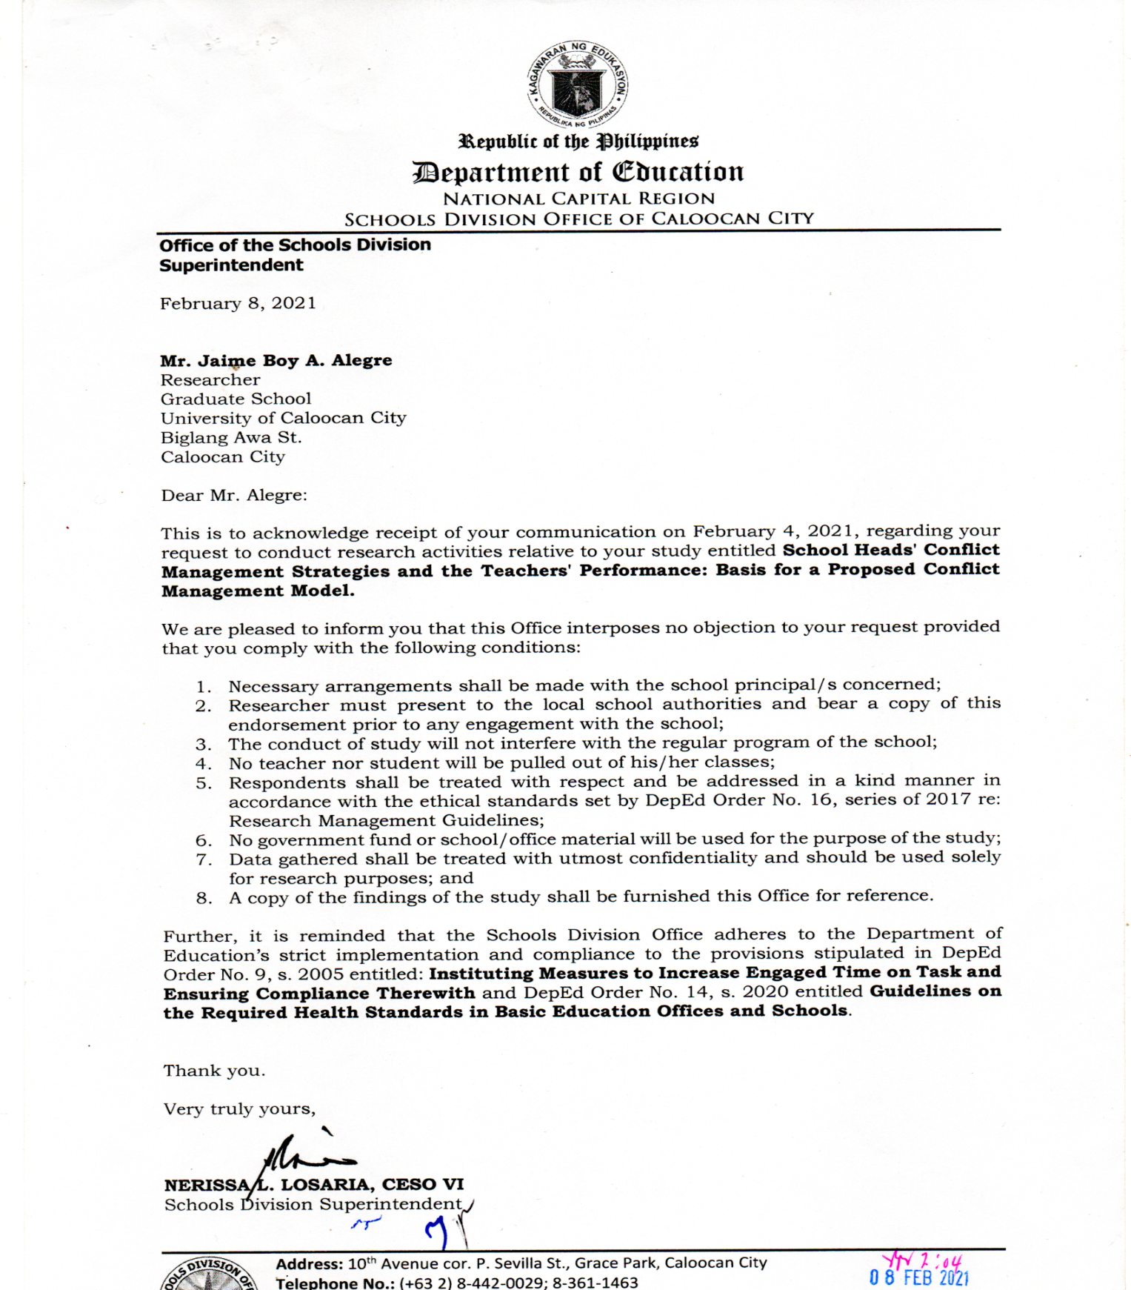



**APPENDIX B**

******Questionnaire**

**University of Caloocan City**

**Biglang Awa Street, Caloocan City**

February 9, 2021

Dear Respondents,

This dissertation study titled, “**School Heads’ Conflict Management Strategies and Teachers’ Performance: Basis for a Proposed Conflict Management Model*”*** is conducted as a requirement for my Doctorate Degree in Philosophy Major in Educational Management at the University of Caloocan City.

The attached survey questionnaire with corresponding rating scale aims to assess the school heads’ management conflict and teachers’ performance. Please read carefully all the items and answer it honestly. Rest assured that all the information gathered through this survey will be used for research purposes only and shall kept confidential.

Thank you very much. God Bless!

Very truly yours,

Jaime Boy A. Alegre

Researcher

**SURVEY – QUESTIONNAIRE**

**(For School Head)**

**Part I. Areas of conflict triggers.**

Directions: Below is a list of indicators of extent of concern on the following conflict triggers. How would you rate the extent of concern you experience/observed in each of the indicators below? Please indicate your answer by checking the appropriate box/column using the scale below.

|  |  |  |
| --- | --- | --- |
| Scale | Range | **Descriptive Rating** |
| 4 | 3.51-4.50 | **Great Extent** |
| 3 | 2.51-3.50 | **Moderate Extent** |
| 2 | 1.51-2.50 | **Little Extent** |
| 1 | 1.00 -1.50 | **Not at all** |

|  |  |  |  |  |
| --- | --- | --- | --- | --- |
| **Conflict Triggers** | GE  (4) | ME  (3) | LE  (2) | Not at all  (1) |
| **A. Work Assignment** |  |  |  |  |
| 1. The hours spent by the teacher in teaching is beyond what is required. |  |  |  |  |
| 2 Teachers teaching assignment requires more than two preparations. |  |  |  |  |
| 3.The subject that teachers teach is outside their area of specialization. |  |  |  |  |
| 4 Teaching assignment in afternoon session of teachers limits their opportunity for extra economic activity for their family. |  |  |  |  |
| 5. Teachers do more clerical tasks than teaching. (e.g., accomplishing LIS forms, preparing LP, and the like) |  |  |  |  |

|  |  |  |  |  |  |  |
| --- | --- | --- | --- | --- | --- | --- |
| **B. Promotion** | |  |  |  |  | |
| 1. I endorse the teachers for promotion based on my assessment of their qualification. | |  |  |  |  | |
| 2. I endorse teachers for promotion who have my trust and confidence. | |  |  |  |  | |
| 3.Copies of Memos announcing the schedule of teacher’s promotion are not read by all the teachers. | |  |  |  |  | |
| 4.Thorough evaluation by superiors of the documents submitted by teachers cannot always be done. | |  |  |  |  | |
| 5. The “palakasan system” sometimes get a space in the promotion process due to external endorsement. | |  |  |  |  | |
| **C. Professional Growth and Development** | |  | |  |  |  |
| 1. Teachers’ attendance to conferences, seminars, workshops, and similar act is limited only to few teachers. | |  | |  |  |  |
| 2.Attendance to conferences, seminars, conferences, and the like by limited number of teachers becomes the subject of controversy and criticism among those teachers who were not given the same chance. | |  | |  |  |  |
| 3. Only few teachers are given the opportunity to participate in a group teaching demonstration. | |  | |  |  |  |
| 4. I do not recognize teachers’ potential capacities in terms of mentoring, peer observation and coaching, as part of their job description. | |  | |  |  |  |
| 5.I send teachers to trainings/ seminars during summer vacation. | |  | |  |  |  |

|  |  |  |  |  |
| --- | --- | --- | --- | --- |
| **D. Inter-Personal Relationship** |  |  |  |  |
| 1. Teachers feel suppressed to discuss their sentiments, disagreements and other grievances with the way things are done in school. |  |  |  |  |
| 2. Two-way communication among teachers is missing that is; they talk more than they listen. |  |  |  |  |
| 3. Teachers express their disagreement with their colleagues through nonverbal messages such as facial expressions, tone of voice, body language, etc. |  |  |  |  |
| 4. Teachers refuse to mingle with others who are not part of their peer group. |  |  |  |  |
| 5. Teachers feel pleased talking with their colleagues about things other than the academics. |  |  |  |  |
| **E. Performance Evaluation** |  |  |  |  |
| 1.Teachers’ performance is evaluated sometimes with limited observations. |  |  |  |  |
| 2.Teachers find personal rather than professional way to get a higher performance rating. |  |  |  |  |
| 3.Teachers’ performance as initially rated by the school head becomes the basis of my overall performance evaluation. |  |  |  |  |
| 4.I evaluated my teachers teaching performance based on my personal judgement. |  |  |  |  |
| 5. The performance evaluation process conducted in our school sets aside the post conference with teachers. |  |  |  |  |

**Part II. School Head Management Strategies**

Instructions: Below is a list of possible management strategies in solving conflicts. To what extent do you practice/use each of the strategies to solve conflict in your school? Please indicate your answer by checking the appropriate box/column using the scale below.

|  |  |  |
| --- | --- | --- |
| Scale | Range | **Descriptive Rating** |
| 4 | 3.51-4.50 | **Great Extent** |
| 3 | 2.51-3.50 | **Moderate Extent** |
| 2 | 1.51-2.50 | **Little Extent** |
| 1 | 0.05-1.50 | **Not at all** |

|  |  |  |  |  |
| --- | --- | --- | --- | --- |
| **Indicators**  **As a school head, I….** | GE  (4) | ME  (3) | LE  (2) | Not at all  (1) |
| 1. call the attention of the teachers concerned and settle the conflict. |  |  |  |  |
| 2.  allow the teachers concerned to give their views and opinions about the conflict |  |  |  |  |
| 3. make the conflicting teachers to discuss their issues in my presence. |  |  |  |  |
| 4. lead the teachers to the settlement of their conflict. |  |  |  |  |
| 1. suggest ways by which the teachers may resolve their conflict. |  |  |  |  |
| 6. refrain from discussing with the teachers’ issues about their conflict |  |  |  |  |
| 7. keep distance from teachers involve in conflict. |  |  |  |  |
| 8. take a neutral ground as I relate with teachers involve in conflict. |  |  |  |  |
| 9. refuse to get in the way to the conflict of teachers. |  |  |  |  |
| 10.  keep myself unmindful of the conflict teachers involve in. |  |  |  |  |
| 11. create/form a committee to look into conflict involving teachers. |  |  |  |  |
| 1. refuse to consider views and opinions of others regarding the conflict involve in by teachers. |  |  |  |  |
| 13. decide towards the resolution of conflict of teachers. |  |  |  |  |
| 14. invoke my authority in resolving teachers’ conflict. |  |  |  |  |
| 15. impose on the teachers the decision I made towards the resolution of their conflict. |  |  |  |  |

**Thank You Very Much!!**

**APPENDIX C**

**SURVEY – QUESTIONNAIRE**

**(For Master Teachers / Teachers 1-3)**

**Part I. Areas of Conflict triggers.**

Directions: Below is a list of indicators of extent of concern on the following conflict triggers. How would you rate the extent of concern you experience in each of the indicators below? Please indicate your answer by checking the appropriate box/column using the scale below.

|  |  |  |
| --- | --- | --- |
| Scale | Range | **Descriptive Rating** |
| 4 | 3.51-4.50 | **Great Extent** |
| 3 | 2.51-3.50 | **Moderate Extent** |
| 2 | 1.51-2.50 | **Little Extent** |
| 1 | 1.00 -1.50 | **Not at all** |

|  |  |  |  |  |
| --- | --- | --- | --- | --- |
| **Conflict Triggers** | GE  (4) | ME  (3) | LE  (2) | Not at all  (1) |
| **A. Work Assignment** |  |  |  |  |
| 1. The hours I spent teaching is beyond what is required. |  |  |  |  |
| 2 My teaching assignment requires more than two preparations. |  |  |  |  |
| 3.The subject I teach is outside our area of specialization. |  |  |  |  |
| 4 My teaching assignment in afternoon session limits my opportunity for extra economic activity for my family. |  |  |  |  |
| 5. I do more clerical tasks than teaching. (e.g., accomplishing LIS forms, preparing LP, and the like) |  |  |  |  |

|  |  |  |  |  |
| --- | --- | --- | --- | --- |
| **B. Promotion** |  |  |  |  |
| 1. My school head endorses the teachers for promotion based on his/her assessment of teachers’ qualification. |  |  |  |  |
| 2.My school head endorses teachers for promotion who has his/her trust and confidence. |  |  |  |  |
| 3.Copies of Memos announcing the schedule of teacher’s promotion are not read by all the teachers. |  |  |  |  |
| 4.Thorough evaluation by superiors of the documents submitted by teachers for promotion cannot always be done. |  |  |  |  |
| 5. The “palakasan system” sometimes geta space in the promotion process due to external endorsement. |  |  |  |  |

|  |  |  |  |  |
| --- | --- | --- | --- | --- |
| **C. Professional Growth and Development** |  |  |  |  |
| 1. Teachers’ attendance to conferences, seminars, workshops, and similar act is limited only to few teachers. |  |  |  |  |
| 2.Attendance to conferences, seminars, conferences, and the like by limited number of teachers becomes the subject of controversy and criticism among those teachers who were not given the same chance. |  |  |  |  |
| 3. Only few teachers are given the opportunity to participate in a group teaching demonstration. |  |  |  |  |
| 4. My school head does not recognize my potential capacities in terms of mentoring, peer observation and coaching, as part of our job description. |  |  |  |  |
| 5.My school head sends me to trainings/ seminars during summer vacation. |  |  |  |  |

|  |  |  |  |  |
| --- | --- | --- | --- | --- |
| **D. Inter-Personal Relationship** |  |  |  |  |
| 1. I feel suppressed to discuss my sentiments, disagreements and other grievances with the way things are done in school. |  |  |  |  |
| 2. Two-way communication among teachers is missing that is; they talk more than they listen. |  |  |  |  |
| 3. I express my disagreement with my colleagues through nonverbal messages such as facial expressions, tone of voice, body language, etc. |  |  |  |  |
| 4. I refuse to mingle with others who are not part of my peer group. |  |  |  |  |
| 5. I feel pleased talking with my colleagues about things other than the academics. |  |  |  |  |
| **E. Performance Evaluation** |  |  |  |  |
| 1.My performance is evaluated sometimes with limited observations. |  |  |  |  |
| 2.I find personal rather than professional way to get a higher performance rating. |  |  |  |  |
| 3.My performance as initially rated by the school head becomes the basis of my overall performance evaluation. |  |  |  |  |
| 4.My school head evaluated my teaching performance based on his/her personal judgement. |  |  |  |  |
| 5. The performance evaluation process conducted in our school sets aside the post conference with teachers. |  |  |  |  |

**Part II. School Heads’ Management Strategies**

Instruction: Below is a list of possible management strategies to solve conflicts in school. To what extent does your school head practice/use each of the strategies to solve conflicts that triggers in your school? Please indicate your answer by checking the appropriate box/column using the scale below.

|  |  |  |
| --- | --- | --- |
| Scale | Range | Descriptive Rating |
| 4 | 3.51-4.50 | Great Extent |
| 3 | 2.51-3.50 | Moderate Extent |
| 2 | 1.51-2.50 | Little Extent |
| 1 | 0.05-1.50 | Not at all |

|  |  |  |  |  |
| --- | --- | --- | --- | --- |
| **Strategies**  **Our school head….** | GE  (4) | ME  (3) | LE  (2) | Not at all  (1) |
| 1. calls the attention of the teachers concerned and settle the conflict. |  |  |  |  |
| 2. allows the teachers concerned to give his/her views and opinions about the conflict |  |  |  |  |
| 3. makes the conflicting teachers discuss their issues in his/her presence. |  |  |  |  |
| 4. leads the teachers to the settlement of their conflict. |  |  |  |  |
| 5. suggest ways by which the teachers may resolve their conflict. |  |  |  |  |
| 6. refrains from discussing with the teachers issues about their conflict |  |  |  |  |
| 7. keeps distance from teachers involved in conflict. |  |  |  |  |
| 8. takes a neutral ground as he/she relates with teachers involved in conflict. |  |  |  |  |
| 9. refuses to get in the way to the conflict of teachers. |  |  |  |  |
| 10.keeps himself/herself unmindful of the conflict where teachers are involved in |  |  |  |  |
| 1 creates/forms a committee to look into conflict involving teachers. |  |  |  |  |
| 12.refuses to consider views and opinions of others regarding the conflict involved in by teachers. |  |  |  |  |
| 13 decides towards the resolution of conflict of teachers. |  |  |  |  |
| 14. invokes his/her authority in resolving teachers’ conflict. |  |  |  |  |
| 15. imposes on the teachers the decision he/she makes towards the resolution of their conflict. |  |  |  |  |

**THANK YOU VERY MUCH!!!**

**APPENDIX D**

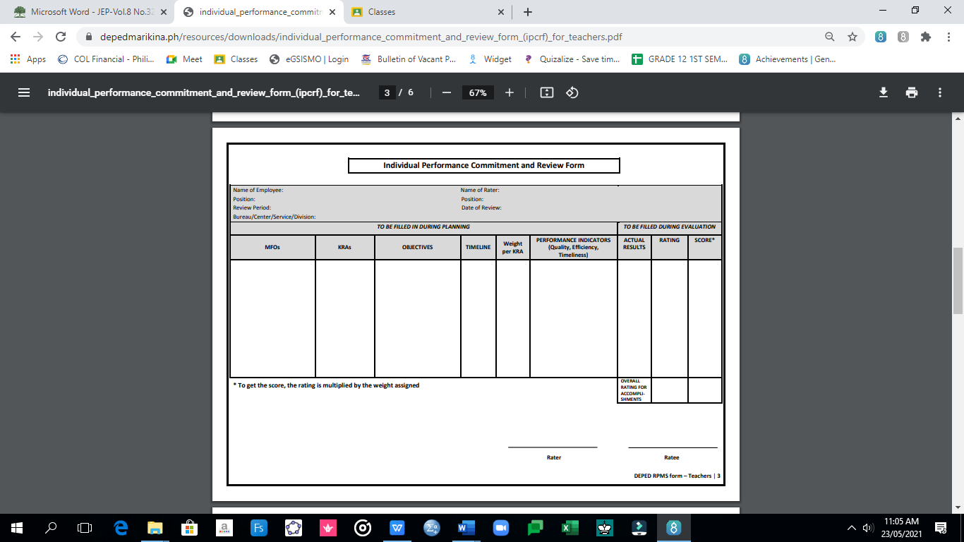**Individual Performance Commitment Review Form**

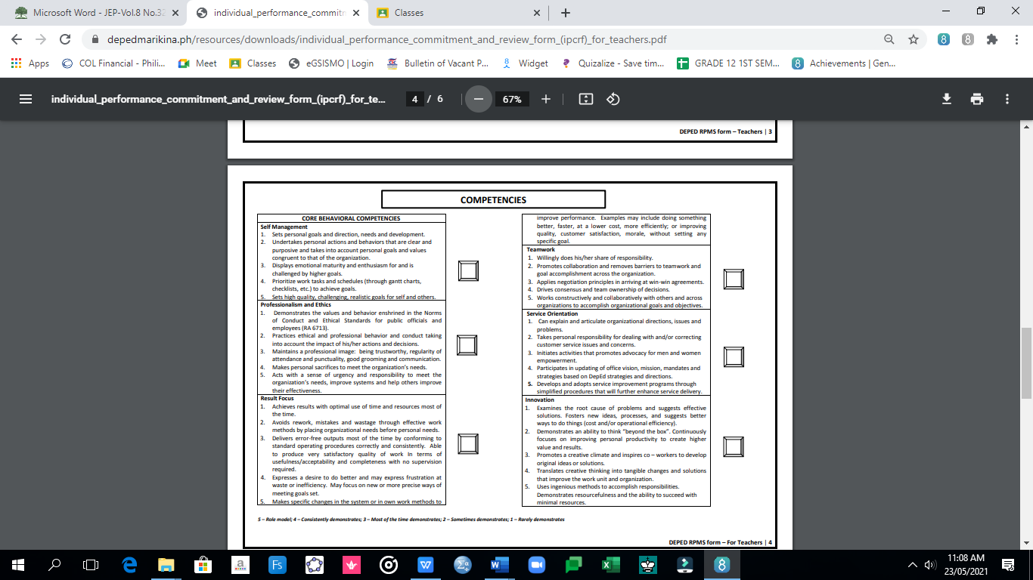

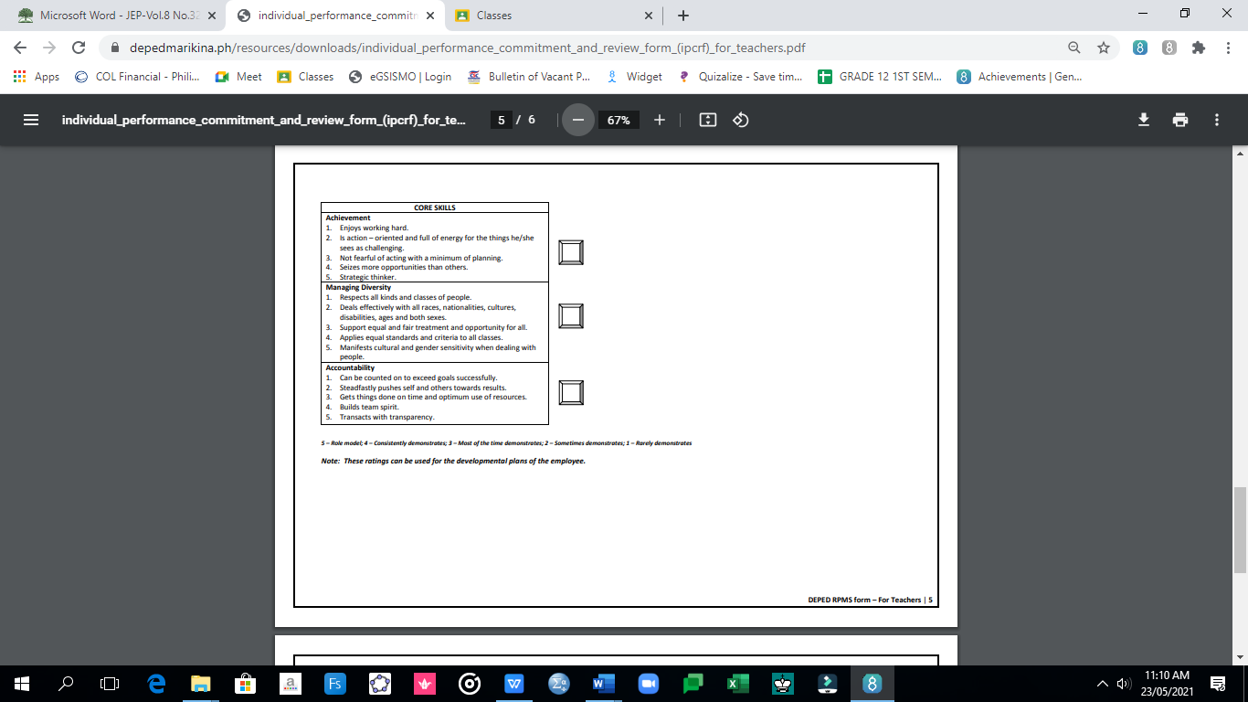

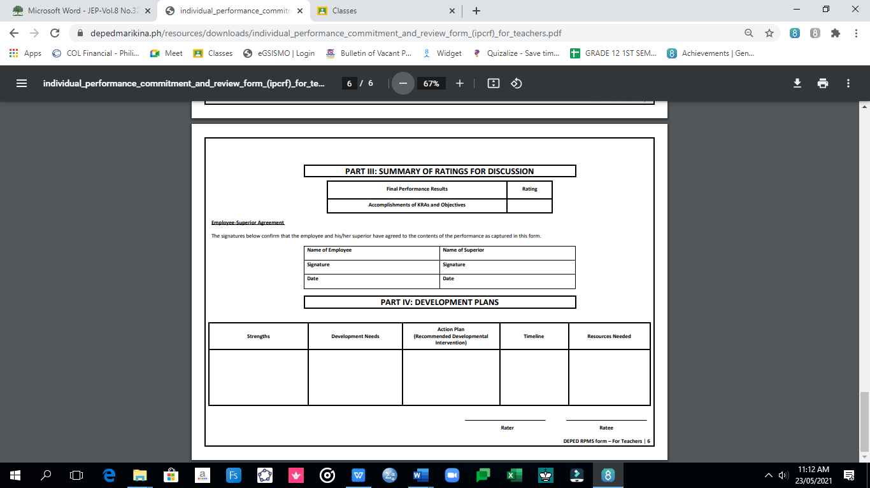

**APPENDIX E**

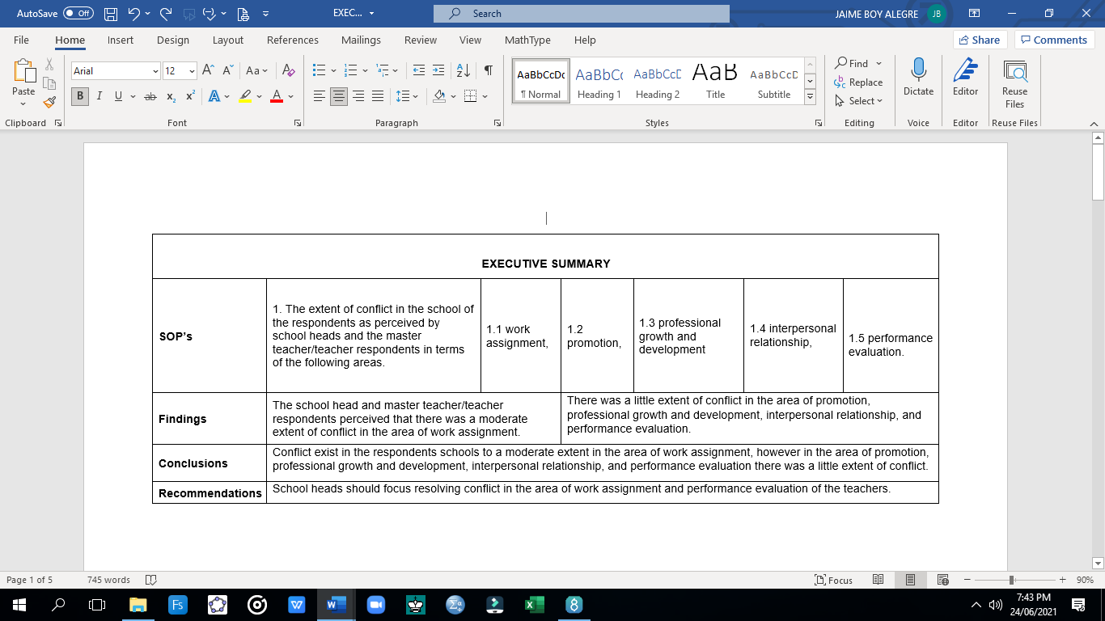**EXECUTIVE SUMMARY**



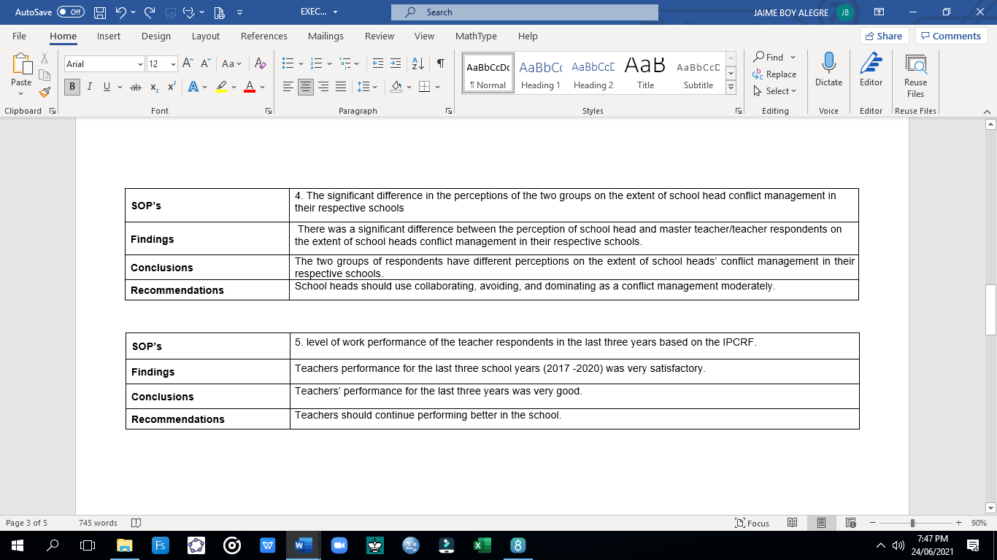

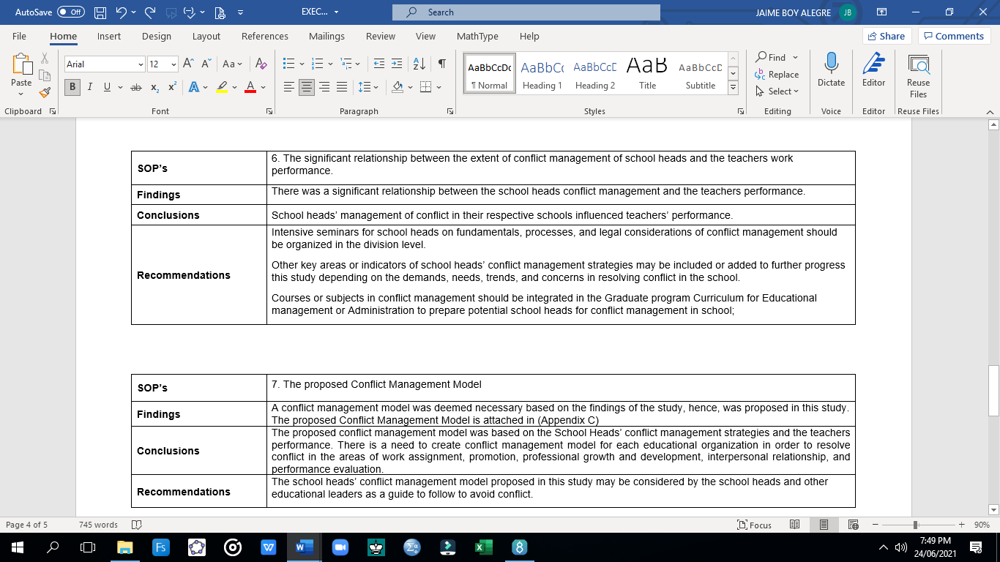

**APPENDIX F**

**CERTIFICATIONS**

**C E R T I F I C A T E OF V A L I D A T I O N**

This is to certify that the research tools for dissertation titled **“School Heads’ Conflict Management Strategies and Teachers’ Performance: Basis for a Proposed Conflict Management Model*”*** presented by **JAIME BOY A. ALEGRE** was validated and passed according to the standards set by the Graduate School of University of Caloocan City.

Given and signed this 26th day of January 2021.

**CHRISTOPHER J. DELINO, EdD**

Principal IV

Valenzuela National High School

**C E R T I F I C A T E OF V A L I D A T I O N**

This is to certify that the research tools for dissertation titled **“School Heads’ Conflict Management Strategies and Teachers’ Performance: Basis for a Proposed Conflict Management Model*”*** presented by **JAIME BOY A. ALEGRE** was validated and passed according to the standards set by the Graduate School of University of Caloocan City.

Given and signed this 26th day of January 2021.

**ARNOLD C. GATUS, EdD**

NCR, Supervisor

**C E R T I F I C A T E OF V A L I D A T I O N**

This is to certify that the research tools for dissertation titled **“School Heads’ Conflict Management Strategies and Teachers’ Performance: Basis for a Proposed Conflict Management Model*”*** presented by **JAIME BOY A. ALEGRE** was validated and passed according to the standards set by the Graduate School of University of Caloocan City.

Given and signed this 26th day of January 2021.

**EVA M. JAVIER, EdD**

Professor, UCC Graduate School

**C E R T I F I C A T E OF V A L I D A T I O N**

This is to certify that the research tools for dissertation titled **“School Heads’ Conflict Management Strategies and Teachers’ Performance: Basis for a Proposed Conflict Management Model*”*** presented by **JAIME BOY A. ALEGRE** was validated and passed according to the standards set by the Graduate School of University of Caloocan City.

Given and signed this 26th day of January 2021.

**ELIZABETH T. MANALO, EdD**

Professor, UCC Graduate School

**CURRICULUM VITAE**

**JAIME BOY AÑORA ALEGRE**

Phase 6 Lot 3 Blk. 3 Lamesa Ville, Lamesa St. Ugong, Valenzuela City

Contact No. 09431012604

Email Address: [jaimeboy.jba@gmail.com](mailto:jaimeboy.jba@gmail.com)

EDUCATIONAL BACKGROUND: 

**GRADUATE STUDIES:**

**UNIVERSITY OF CALOOCAN CITY**

Doctor of Philosophy - Major in Educational Management

Biglang Awa St. Caloocan City

2016-2021

**MEYCAUAYAN COLLEGE**

Master of Arts in Education – Major in Mathematics

Meycauayan, Bulacan City

2016 – 2018

**PAMANTASAN NG LUNGSOD NG VALENZUELA**

Master of Arts in Education - Educational Management (2013)

Valenzuela City

**TERTIARY:**

Surigao State College of Technology

Bachelor of Secondary Education – Major in Mathematics

Surigao City, Mindanao

2000 – 2004

**SECONDARY:**

GIGAQUIT NATIONAL SCHOOL OF HOME INDUSTRIES

Alambique, Gigaquit Surigao del Norte

1996 – 2000

**PRIMARY:**

GIGAQUIT CENTRAL ELEMENTARY SCHOOL

Alambique, Gigaquit Surigao del Norte

1990 – 1996

**PROFESSIONAL EXAMINATION PASSED:**

LICENSURE EXAMINATION FOR TEACHERS

August 2005

**AWARDS AND SPECIAL RECOGNITION**

Gold Medal of Merit Teachers‟ RUBIKS Competition

Division Level 2012-2016

Bronze Medal Best Strategic Intervention Material (SIM)

Division Level 2012

Third Runner-Up Best Demonstration Teacher

Division Level 2010

Second Place Best Strategic Intervention Material (SIM)

Division Level 2010

First Runner- Up in Search for the Best Demonstration Teacher

School Level 2010

**SEMINARS AND TRAININGS ATTENDED:**

8 Days National Webinar on Critical Thinking for DepEd Potential Leaders

March 7-8, 13-14, 20-21, 27, 2021

Effective Delivery of Synchronous/Asynchronous Teaching

March 15 - 19, 2021

Critical Role in Assessment in Online Learning

March 15 - 19, 2021

Interactive Instructional Materials

March 15 - 19, 2021

Technology Integration and Instructional Materials Development

March 15 - 19, 2021

Community Based Activities for Positive Discipline

January 17-18, 2017

Division Training Workshop on Practical Research 1 and 2

December 2017

**WORK EXPERIENCE:**

ABM, HE, GAS, ICT GEN. MATH and STATISTICS SHS TEACHER

GEN.T.DE LEON NATIONAL HIGH SCHOOL

STATISTICS AND RESEARCH TEACHER

OUR LADY OF LOURDES COLLEGE

FOOD HANDLER

ANDOKS LITSON CORPORATION

QUALITY CONTROL (CHECKER)

ADRIATIC MANUFACTURING CORPORATION

INTERNAL OFFICER

GAISANO INTERFACE CORPORATION

**PERSONAL DATA:**

Date of Birth : July 26, 1984

Place of Birth : Surigao del Norte

Civil Status : Married

Religion : Roman Catholic

Height : 5’6”

Weight : 60 kilograms.

Languages Spoken : Surigaonon, English and Filipino

**CHARACTER REFERENCES:**

ANALIZA N. DOMINGO

SHS Assistant Principal, Gen. T. de Len NHS

RODNEY A. ORTIZ

Head Teacher- Math Department, Gen. T. de Leon NHS

I hereby swear that the information above are true and correct to the best of my knowledge.

**Jaime Boy Añora Alegre**

Signature